Prelab Question 7
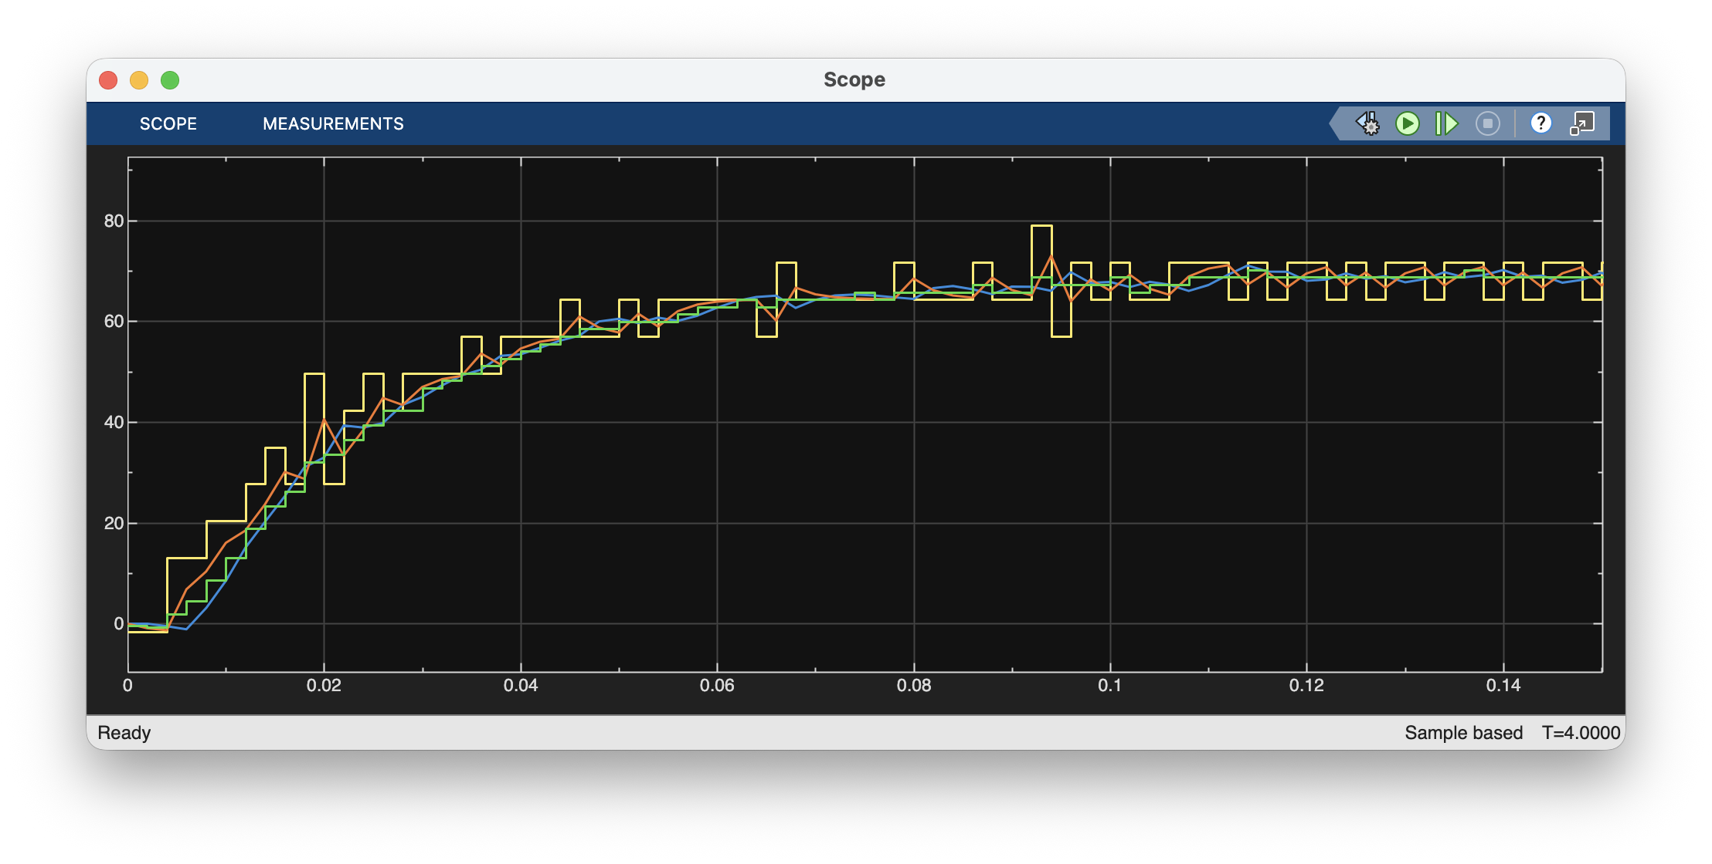
fc = 45;
zeta = 0.707;
WindowSize = 5; 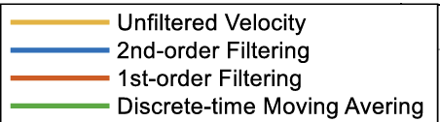

Prelab Question 8
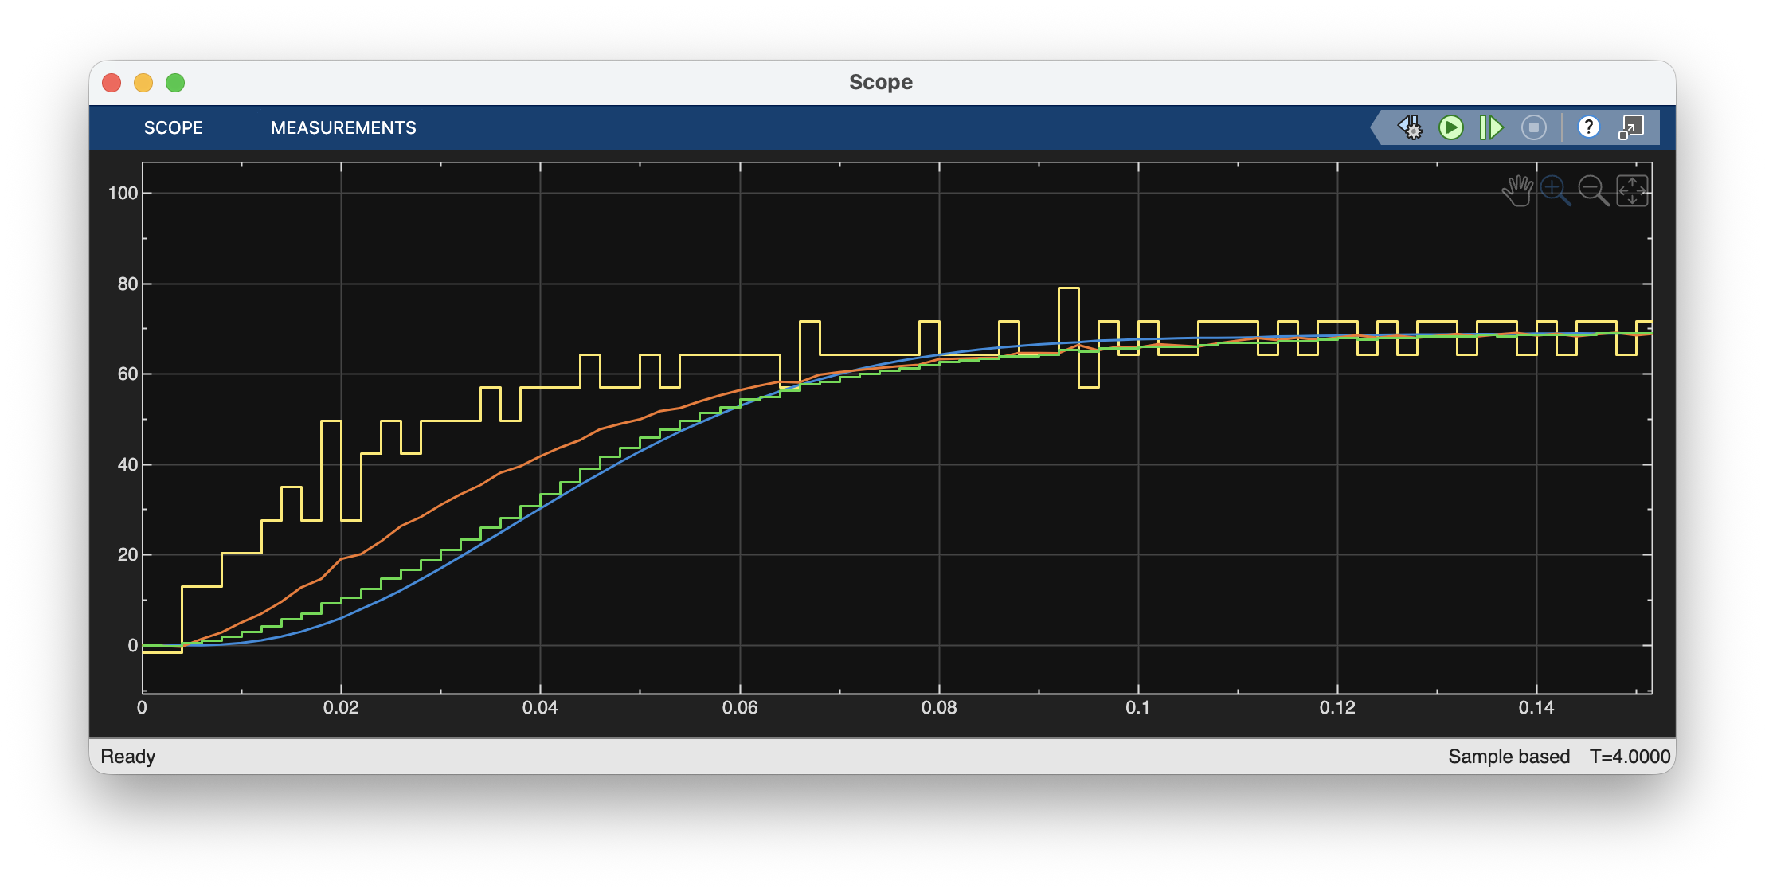
fc = 10;
zeta = 0.707;
WindowSize = 22;

Question 9:
Explain the trade-off between smoothness and shape preservation in filtering the measured data after you tried two cut-off frequencies. Describe the conditions that lead to over-filtering versus under-filtering.

In the first graph, all the filter outputs track the rough behaviour of velocity. However, noise is still evident in the outputs.

In the second graph, noise is much more minimal. But the filter outputs do not accurately track the actual behaviour of the curve. This is especially evident in the first 0.06 seconds where all filtered outputs are consistently lower than the actual velocity observed.

This means that overfiltering is occurring. This occurs when the cutoff frequency is far lower than the actual bandwidth of the signal.

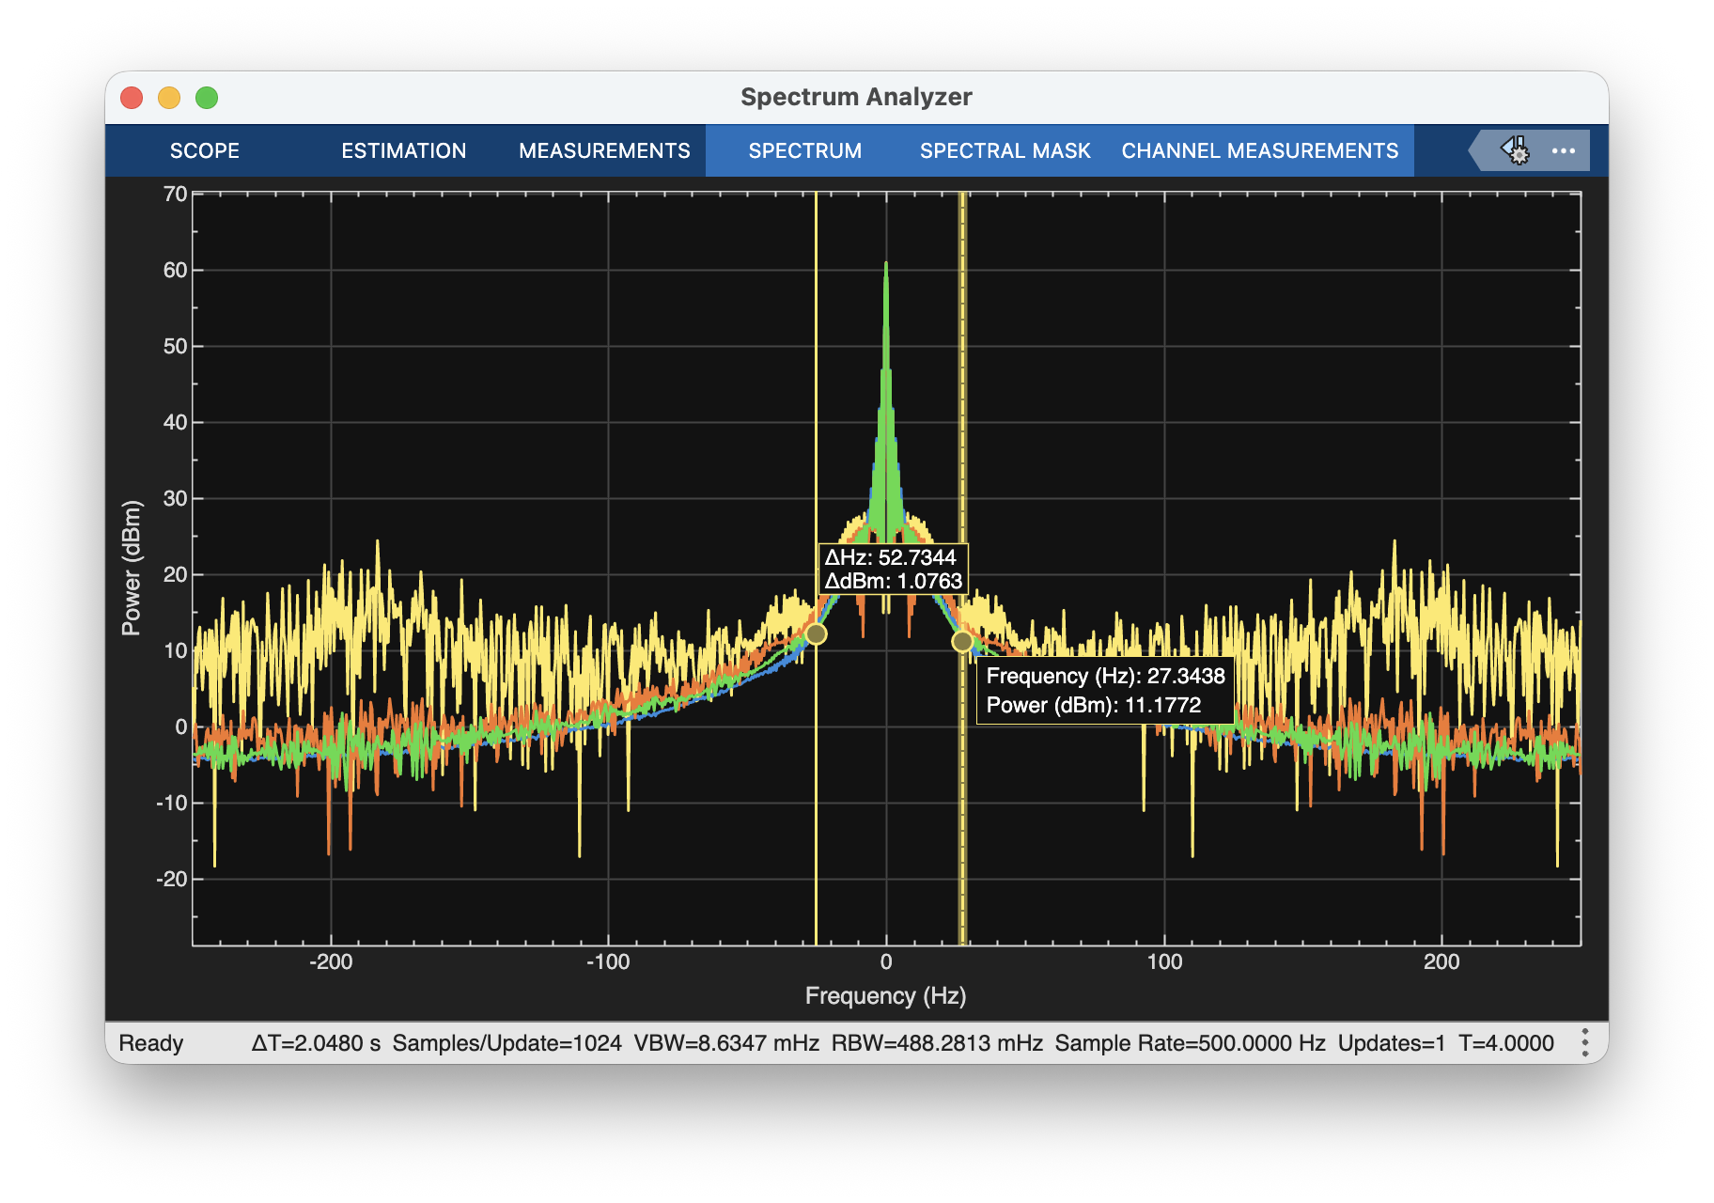
We can see from the spectrum analyser that most of the constituent frequencies of the signal are between +/- 30 Hz, so it makes sense that when we make the cutoff 10 Hz we lose data which is valuable.

Question 10:
Explain how the Spectrum Analyzer can be used to select the optimal filter cut-off frequency, using the unfiltered data frequency response. Simulink plots the frequency response of any signal connected to the Spectrum analyser as shown in Fig. 1-10. You can click on each graph legend to hide or unhide a plot.

The spectrum analyser tells us the contribution of each frequency to the signal. From this, it is easy to see what frequency the ’ noise ’ is since it doesn’t follow any observable pattern.

Question 11:
Considering complexity, performance, and practical implementation, which filter best reduces noise while preserving core signal information, and why?
The second order filter. It minimises noise without heavily overfiltering useful data. However, the cutoff frequency should be adjusted slightly so that the initial behaviour is not under-represented.

